Parent Communication Toolkit

This tool kit is designed to help educators communicate with parents about student progress and project-based learning. Consider this as a starter kit that we will add to over the course of the year based on your needs and feedback. We hope you can use this tool kit to:

- Share the value of project based-learning with parents.
- Share with prospective families to help them see the type of learning you offer.
- Bring parents into the learning process by sharing tools and tips to help them engage at home.
- Support showcase and sharing of student work.
- Promote and support student reflection.

This document includes:
- Welcome Letter: A brief welcome letter that explains project-based learning and it’s benefits.
- Outcomes Overview: A brief overview of the outcomes supported by a project.
- Showcase Invite: An invitation you can use or adapt to invite parents or family members to see students present on their projects.
- Parents’ Showcase Reflections: A reflection activity for parents to complete during a showcase, designed to celebrate and highlight students’ strengths and achievements as they present their Take Action Project.
- How I Can Help: A simple “how I can help” at home guide you can share with parents about how they can support their students at home.

These tools are optional and can be used as is or customized for your context. Share all these resources or one at a time as needed.

Welcome Letter

Hello families,

I’m very excited to share some exciting news about a program we’ll be using this year at our school.

Rock by Rock is a project-based learning program that helps students learn in real-world ways while building key academic skills like reading and science.

What is Project-Based Learning (PBL)?
PBL is an approach to teaching where students learn by actively engaging in real-world and personally meaningful projects. Students start with a real-world mission or problem to solve. Students then engage in reading, writing, science, social studies, critical thinking, problem solving, and creativity to understand the problem they are solving and to generate a solution.

Why is Project-Based Learning Important?
In the real-world, students use all their knowledge and skills in context to solve a real problem. Project-based learning gives students a chance to learn this way in school. Project-based learning is important to start in early grades so students can build key skills at an early age. Project-based learning has many benefits:
- Improved Literacy: Improves vocabulary and world knowledge which helps students become stronger readers and writers.
- Improved Science: It helps improve students' knowledge and skills in science.
- Engagement: Real-world projects are more relevant and meaningful and increase student engagement in learning.
- Life Habits: Projects build life skills like problem solving, teamwork and critical thinking that students will need in our fast changing world.
- Love: Projects can help foster a love of life long learning.

How do students learn through projects?
We will use Rock by Rock’s library of real-world projects. Each Rock by Rock project blends online and hands-on learning so students can experience the best of both worlds. Projects challenge kids to build science, reading and life habits while studying a real-world problem. Kids then create a project that helps take real-world action to solve a problem.

Each project includes:
A Student Mission | Inquiry and Investigation | Take Action Project
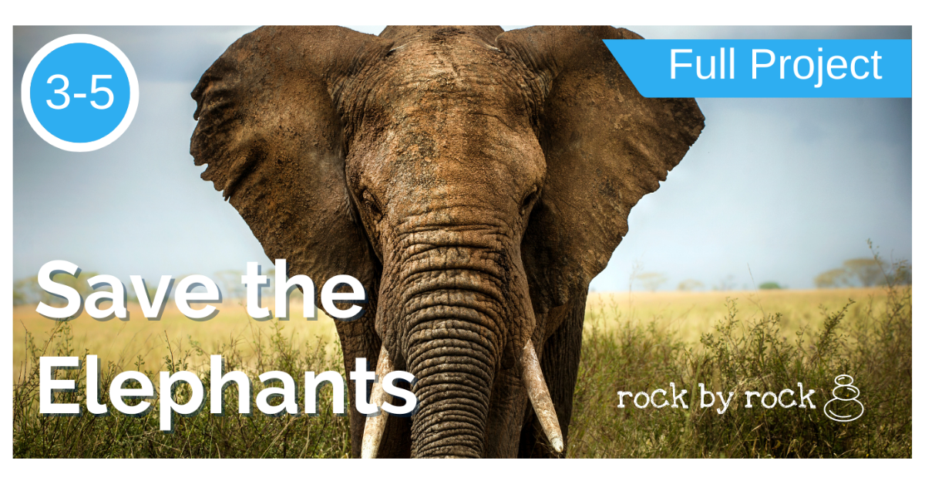 | 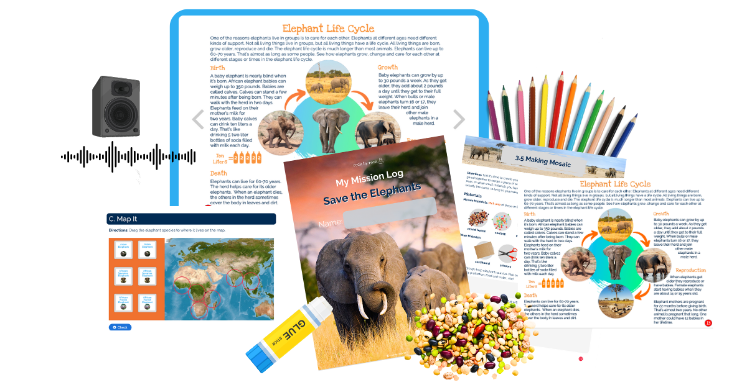 | 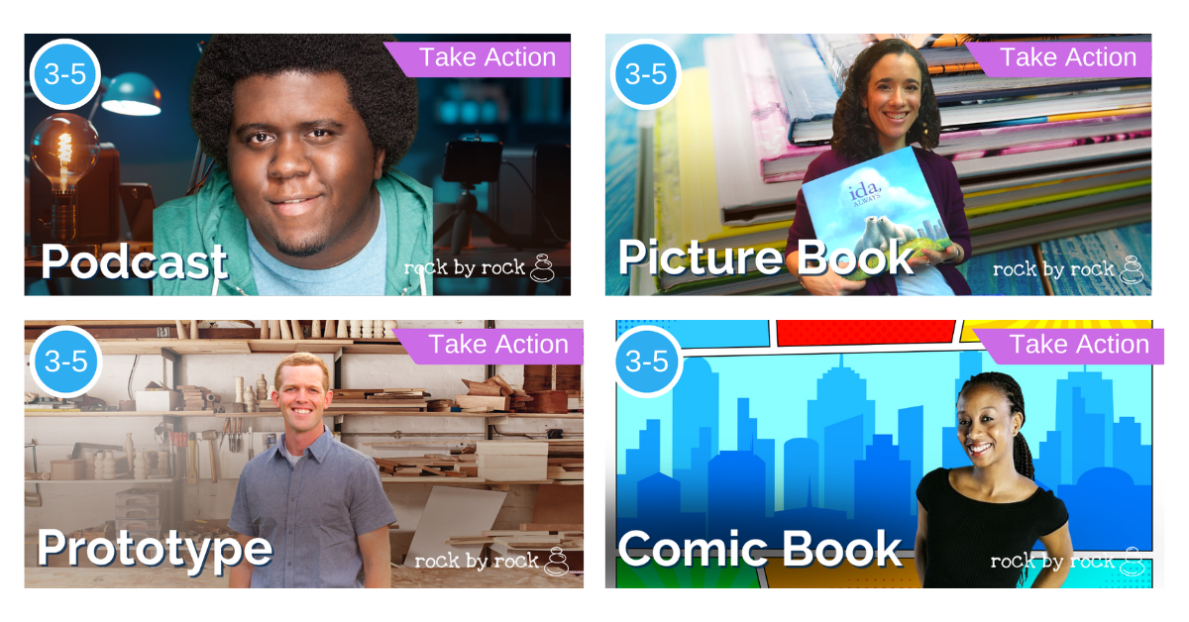
Each project has a mission or real-world problem students will solve. Some missions are global and others impact our local community. | Each project challenges students to think, learn and grow through reading, experiments, video, models, games and activities. | After students understand the problem, they complete their mission with a final take action project that helps solve the problem. Each mission builds real-world skills that help solve the problem and set students up for success in the future.

How can I be involved?
Project-based learning provides two key ways for you to be involved as a parent:
- Reflection and discussion: Students will be learning a ton of knowledge they will be excited to share and discuss. Asking students every day what they learned about their mission is a great way to continue the conversation at home.
- Showcase: At the end of each project students will present their final project. You can visit us at school to see their final project, have students present at home or practice at home before the showcase.

We’re thrilled to engage your learners through real-world projects and look forward to the rich conversations, discussions and learnings that will come from our project-based learning journey together. If you have any questions, don’t hesitate to reach out!

Sincerely,
<NAME>

Outcomes Overview
This year, our Rock by Rock projects will help your child grow in three key areas that will benefit them now and later in life. We share this list so you can both see some of the many benefits of project-based learning and help students reflect on their progress at home.

Academic Content and Skills  Focuses on the set of skills we know kids need to demonstrate they are growing in their intellectual capacities. | Life Habits  These are the transferable life skills that we know kids need to develop starting at a young age in order to thrive now and in the future. | Purpose and Sense of Self  These are the set of personal development skills that drive a student’s sense of purpose and identity throughout their development as a learner.
K-2 Students | Learner  “I try my best to learn and grow.” | Passions & Purpose  “I know about my passions and areas of interest.”
Learn Content  “I can explain an important problem in our world.” | Learner  “I try my best to learn and grow.”
Create and Explain a Solution  “I can take action to help solve that problem. | Curiosity  “I ask questions to look for answers so I can learn and grow,” | Strengths  “I’m aware of my strengths and areas of growth.”
Communicate Effectively  “I can take action by sharing solutions with others.” | Creativity  “I create new ideas and new ways to do things.” | Emotions  “I’m aware of my emotions and how they impact me and others.”
3-5 Students | Empathy  “I think about how others feel and try to understand them.”
Understand the Need or Problem  “I can explain the problem, why it exists and support my understanding with science.” | Kinship  “I care about others and my community.”
Make a Strong Argument and Solution  “I use claim, evidence, and reasoning to help people understand the problem and show them how they can make a difference.” | Impact Awareness  “I think about how my actions affect me, others, my community and my world.”
Communicate Effectively with Others  “I share my project in a way that makes people trust me and want to take action.” | Courage  “I stand up to challenges and keep going when things feel hard.”
Showcase Invite
Hello Families,
We are thrilled to invite you to a special event celebrating your students’ incredible work on their latest Rock by Rock project. The <Project Name> Showcase is an opportunity for students to present their Take Action Project and share how they tackled a real-world mission using the skills and knowledge they’ve developed.

Event Details
Who: Students and their families
What: <Project Name> Showcase featuring student Take Action Projects
When: [Insert Date and Time]
Where: [Insert Location]
Why: To celebrate your students’ hard work, creativity, and learning

RSVP
Please RSVP by [Insert Deadline] to [Insert RSVP Email/Link] and let us know who will be attending.
We hope you can join us for this special celebration of your child’s progress and achievements. It’s a chance for families to come together, reflect on student growth, and see the impact of project-based learning in action.
Thank you for supporting your student on their learning journey. We can’t wait to celebrate with you at the showcase!
Warm regards,
[Your Name]

Parents’ Showcase Reflection

Thank you for joining us at the <Project Name> showcase! We’re thrilled to have you here to celebrate your child’s progress. As you watch them present their Take Action Project, look out for the academic skills they demonstrated and jot them down so we can all celebrate their hard work and achievements together!

K-2 Academic Skills Rubric
 | Learn Content:  “I can explain an important problem in our world.” | Create a Solution:  “I can take action to help solve that problem. | Communicate Effectively With Others: “I can take action by sharing solutions with others.”
Criteria | I can explain the problem in my own words.  I can use 2-3 pieces of evidence to explain what causes the problem.  I can explain at least 1-2 ways to fix the problem | I made, wrote or built something to help solve the problem.  I can explain how my solution helps solve the problem with 1-2 examples.  I can explain why I made the choices I made in my design. | I make good eye contact with my audience.  I speak slow enough, loud enough, and clearly enough for people to understand me.
Examples
3-5 Academic Skills Rubric
 | Understand the Problem or Need:  “I can explain the problem, why it exists and support my understanding with science.” | Make a Strong Argument and Solution:  “I use a claim, evidence, and reasoning to help people understand the problem and show them how they can make a difference.” | Communicate Effectively With Others:  “I share my project in a way that makes people trust me and want to take action.”
Criteria | Problem: I can state the problem in my own words.  Cause: I can explain the problem with 3-4 scientific concepts.  Solution: I can explain potential solutions to the problem and the pros and cons of those solutions. | Claim: My project makes a clear claim about how to solve the problem.  Evidence: I support my claim with 3-4 pieces of strong, relevant evidence.  Reasoning: I explain how my evidence clearly supports my claim so people are compelled to use my solution or take action. | Organization: People can follow my organized ideas clearly because the order makes sense.  Word Choice: I use words and phrases (first/second/if/then/but/because/so) so people easily follow my ideas.  Connection: I make good eye contact with my audience.  Communication: I speak slowly enough, loudly enough, clearly enough and with confidence so people can understand me, believe me and want to take action.  Multimedia: I use media, images, sound, or technology to help people see, understand, believe and take action.
Examples

How Can I Help Tip Sheet

As a parent there are many ways you can support and encourage your students' projects and growth at home. Here are just a few high impact ways you can support.

Strategy | Things you can do:
Ask Questions: | Asking questions after school is a great way to help students process their learning and share their enthusiasm for what they learned. Here are a few questions you can ask:  - What is the mission of your project?  - What did you learn today to help you with your project mission?  - What is one thing that surprised you about your project?  - What do you think you will do to take action?
Extend Learning: | Often, projects serve as a springboard for extended learning. Students may want to explore the project in greater depth or be inspired to explore related topics.  - Read books related to the project.  - Watch a movie or video related to the project’s mission.  - Go to the library together to explore related books.  - Pick a question you want to research together.
Attend Showcase: | Many of our projects will end with a showcase where students will present their project. We hope you, your family and even friends of the family can join to see students present their projects and celebrate their success.
Support Reflection: | Students will learn about themselves and our world through each project. Helping students process what they are learning is a great way to help them grow as individuals outside of the school day. Consider asking:  - What is your favorite thing you learned?  - What have you learned about yourself doing this project?  - What are your strengths and what are you doing really well?  - What do you want to get better at? Why?

